INFOIBV 2023, Assignment1, Muhammed Budak (2154676) , Süleyman Taşkın (8460051)

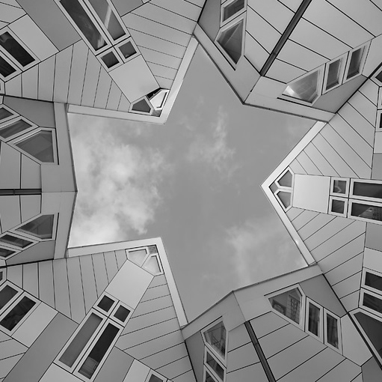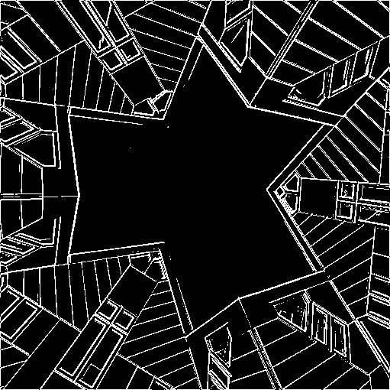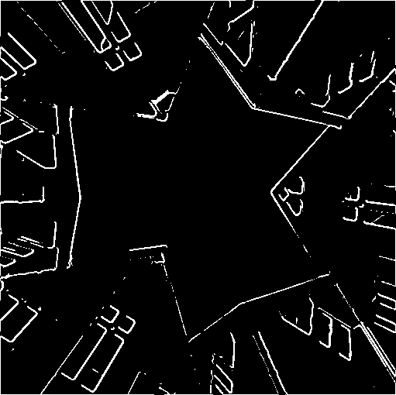

Image A (Converted to grey- Image B ( 5x5 gaussian filter- Image C ( 5x5 median filter-

scale and, contrast adjusted ed, edge detected and, 100 ed, edge detected and, 100

loaded coloured image) as threshold applied image) as threshold applied image)

Answer 1. The median filter is a non-linear filter. So, in some part of the image it gives the middle item in the sorted filter region. There is some contrast degradation and some values goes under threshold. Therefore some edges is lost (Image C). On the other hand, Gaussian filter is a low pass linear filter and allows this kind of components can pass (Image B) so the edges are still exist for the same sized filter.

Answer 2. Gaussian Filter is a low pass filter. The role of sigma in the Gaussian filter is to control the variation around its mean value. A large sigma value results in a flatter shape, while a smaller sigma value results in a more pronounced peak. So, when the sigma is increased we see the broad scene without paying attention to details. Local contrast decreases, more smoothing and blurring occurs. So, kernel size or sigma value should be chosen to find how much noise wanted to be reduced and how much structural details needed to be keep.

When Median filter size increase more pixel values getting in the consideration. So, the probability of coming more different pixel value then the central value increases. And computational cost increases.

Finally, filter size should be big enough to reduce noise and not eliminate the important features of the image itself.

Answer 3. The optimal sigma depends on image factors - primarily the resolution of the image and the size of objects in it (in pixels). Filter Kernel should be big enough to cover most of the desired objects, but not so large that it starts overlapping multiple neighbouring objects at a time. Larger kernels have more values factored into the average, that blur the image more.

As shown below, if the kernel size increases more pixel getting in the consideration so smoothing and blurring pronounced, local contrast reduced so that after edge detection and threshold some edges are vanished when filter size (kernel size) increases.

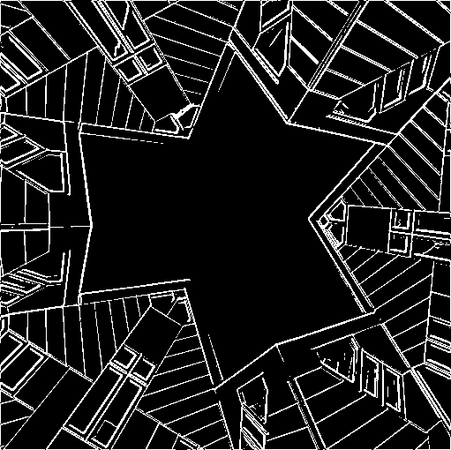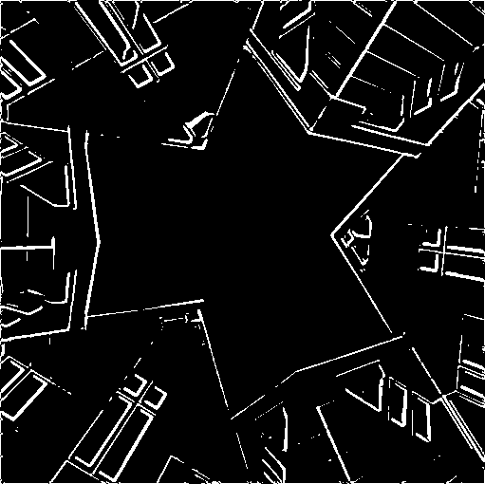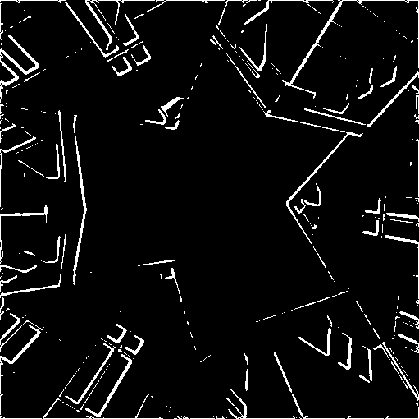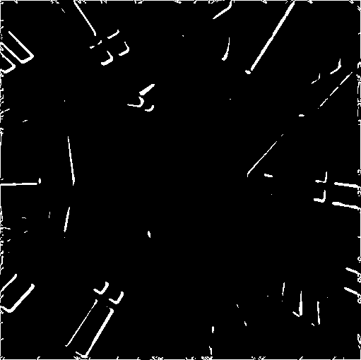

(Kernel=3x3, (Kernel=5x5, (Kernel=7x7, (Kernel=9x9, (Kernel=11x11,

Sigma= 1) Sigma=1.5) Sigma=2) Sigma=2.5) Sigma=3)

